**Random Forests for Regression Problems**

**Introduction:**

The goal of the blogpost is to equip beginners with basics of Random Forest Regressor algorithm and quickly help them to build their first model. We will mainly focus on the modeling side of it. The data cleaning and preprocessing parts would be covered in detail in an upcoming post.

**Ensemble methods** are supervised learning models which combine the predictions of multiple smaller models to improve predictive power and generalization.

The smaller models that combine to make the ensemble model are referred to as **base models**. Ensemble methods often result in considerably higher performance than any of the individual base models could achieve.

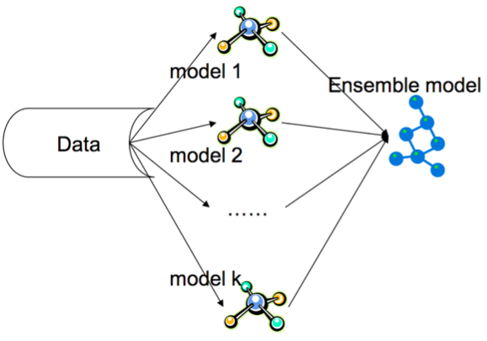

## **Two popular families of ensemble methods**

**BAGGING**

Several estimators are built independently on subsets of the data and their predictions are averaged. Typically the combined estimator is usually better than any of the single base estimator.

**Bagging can reduce variance with little to no effect on bias.**

ex: Random Forests

**BOOSTING**

Base estimators are built sequentially. Each subsequent estimator focuses on the weaknesses of the previous estimators. In essence several weak models "team up" to produce a powerful ensemble model. (We will discuss these later this week.)

**Boosting can reduce bias without incurring higher variance.**

ex: Gradient Boosted Trees, AdaBoost

## **Bagging**

The ensemble method we will be using today is called **bagging**, which is short for **bootstrap aggregating**.

Bagging builds multiple base models with **resampled training data with replacement.** We train kk base classifiers on k different samples of training data. Using random subsets of the data to train base models promotes more differences between the base models.

We can use the **BaggingRegressor** class to form an ensemble of regressors. One such Bagging ressor algorithm is **random forest regressor**. A random forest regressor is a meta estimator that fits a number of classifying decision trees on various sub-samples of the dataset and use averaging to improve the predictive accuracy and control over-fitting. The sub-sample size is always the same as the original input sample size but the samples are drawn with replacement if bootstrap=True (default).

Random Forest Regressors uses some kind of splitting criterion to measure the quality of a split. Supported criteria are “mse” for the mean squared error, which is equal to variance reduction as feature selection criterion, and “mae” for the mean absolute error.

Enough of theory , let’s start with implementation.

**Problem Statement :**

To predict the median prices of homes located in boston area given other attributes of the house.

**Data details**

Boston House Prices dataset  
===========================  
  
Notes  
------  
Data Set Characteristics:   
  
 :Number of Instances: 506   
  
 :Number of Attributes: 13 numeric/categorical predictive  
   
 :Median Value (attribute 14) is usually the target  
  
 :Attribute Information (in order):  
 - CRIM per capita crime rate by town  
 - ZN proportion of residential land zoned for lots over 25,000 sq.ft.  
 - INDUS proportion of non-retail business acres per town  
 - CHAS Charles River dummy variable (= 1 if tract bounds river; 0 otherwise)  
 - NOX nitric oxides concentration (parts per 10 million)  
 - RM average number of rooms per dwelling  
 - AGE proportion of owner-occupied units built prior to 1940  
 - DIS weighted distances to five Boston employment centres  
 - RAD index of accessibility to radial highways  
 - TAX full-value property-tax rate per $10,000  
 - PTRATIO pupil-teacher ratio by town  
 - B 1000(Bk - 0.63)^2 where Bk is the proportion of blacks by town  
 - LSTAT % lower status of the population  
 - MEDV Median value of owner-occupied homes in $1000's  
  
 :Missing Attribute Values: None  
  
 :Creator: Harrison, D. and Rubinfeld, D.L.  
  
This is a copy of UCI ML housing dataset.  
<http://archive.ics.uci.edu/ml/datasets/Housing>  
  
This dataset was taken from the StatLib library which is maintained at Carnegie Mellon University.  
  
The Boston house-price data of Harrison, D. and Rubinfeld, D.L. 'Hedonic  
prices and the demand for clean air', J. Environ. Economics & Management,  
vol.5, 81-102, 1978. Used in Belsley, Kuh & Welsch, 'Regression diagnostics  
...', Wiley, 1980. N.B. Various transformations are used in the table on  
pages 244-261 of the latter.  
  
The Boston house-price data has been used in many machine learning papers that address regression  
problems.

**Tools used**:

Pandas , Numpy , Matplotlib , scikit-learn

**Python Implementation with code:**

1. **Import necessary libraries**

Import the necessary modules from specific libraries.

|  |
| --- |
|  |

1. **Load the data set**

Use pandas module to read the taxi data from the file system. Check few records of the dataset.

|  |
| --- |
|  |

1. **Select the predictor and target variables**

|  |
| --- |
|  |

1. **Train test split :**

|  |
| --- |
|  |

**5. Training / model fitting :**

Fit the model to selected supervised data

|  |
| --- |
|  |

1. **Model parameters study :**

The coefficient R^2 is defined as (1 - u/v), where u is the residual sum of squares ((y_true - y_pred) ** 2).sum() and v is the total sum of squares ((y_true - y_true.mean()) ** 2).sum().

|  |
| --- |
|  |

1. **Find out the Accuracy with test data:**

Visualize the goodness of the fit with the predictions being visualized by a line

|  |
| --- |
|  |

1. **What are your conclusion**s?